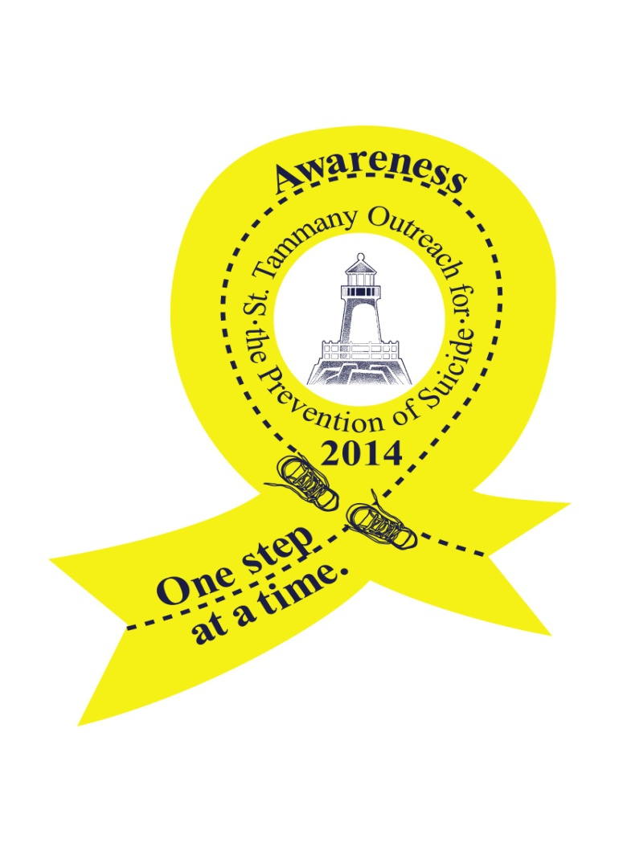
One Step At A Time-Suicide Awareness 5K Walk/Run
Sponsorship Opportunities
Please join St. Tammany Outreach for the Prevention of Suicide (STOPS) as we host our first “One Step At A Time” 5K Walk/Run to promote suicide awareness and prevention in our community on Saturday, September 20th in Abita Springs. As you know, although St. Tammany is a very desirable place to live, work and raise a family, it is also a place with one of the highest suicide rates in the state, about 18% above the state average. STOPS is a non-profit, volunteer organization that was formed in 2001 to address the serious problem of suicide in our parish. Our mission is to reduce the incidence of suicide and its devastating aftermath in our community. By fostering prevention, intervention and postvention resources, we seek to create a community safety net for individuals and families in crisis.
Programs include Local Outreach to Suicide Survivors (LOSS Team), in conjunction with the Sheriff’s office and Coroner’s office. This team comes to the immediate aid of families who lose a loved one to suicide. Two STOPS volunteers are sent to the scene of every suicide in the parish. They offer comfort and support, share their own experiences, and provide resources to the family, such as counseling options and the Survivors of Suicide (SOS) support group. STOPS also offers two suicide prevention trainings: safeTALK and ASIST (Applied Suicide Intervention Skills Training), among other outreach to the community.
Please consider sponsoring this most worthy event for the inaugural run!

Sponsorship Levels
(Please check your selection)
______Speed of Light – (exclusive presenting sponsor) $5,000
10 T-shirts and race registrations
Recognition as the presenting sponsor at the post-race celebration, on the STOPS Website, press releases, radio spots, Facebook, race banner and promotional materials
Logo and name on t-shirt and other promotional materials
_______Sprinter - $1,000 sponsor
8 T-shirts and race registrations
Recognition as a sponsor at the post-race celebration and on the STOPS Website
Logo and name on t-shirt and other promotional materials
_______Light Jogger - $500 sponsor
6 T-shirts and race registrations
Recognition as a sponsor at the post-race celebration and on the STOPS Website
Logo and name on t-shirt and other promotional materials
_______Power Walker - $250 sponsor
4 T-Shirts and race registrations
Recognition as a sponsor at the post-race celebration and on the STOPS Website
Name on t-shirt and other promotional materials
_______Baby Stepper - $100 sponsor
2 T-Shirts and race registrations
Recognition as a sponsor at the post-race celebration and on the STOPS Website
Name on t-shirt

In-Kind Sponsors will be listed on the race t-shirt
SPONSORSHIP INFORMATION FORM
Please Remit To:
S.T.O.P.S.
Attn: One Step At A Time 2014
427 N. Theard Street, #500
Covington, La 70433
985-237-5506

NAME OF INDIVIDUAL OR COMPANY SPONSOR_______________________________________________

CONTACT PERSON______________________________________________________________________

PHONE NUMBER_______________________________________________________________________

ADDRESS_____________________________________________________________________________

EMAIL________________________________________________________________________________
Please make checks payable to S.T.O.P.S.
***IN KIND SPONSORS PLEASE INDICATE SPECIFIC DONATION AND ITS VALUE***

